URL: https://lashesbyaree.com/classic-lash-extensions/

Focus Keyword | Secondary Keyword
classic lash extensions | classic lash extensions near me  classic lash extensions houston  before and after classic lash extensions  natural classic lash extensions  Classic lash fill  Classic lash look  Natural eyelash extensions

Your Dream Classic Lash Extensions Journey Starts Here (H2)

Initial Consultation (H3) | Application Time (H3) | Aftercare Tips (H3)
At Lashes by Aree, we do not take you straight to the application process. When you are scheduling your appointment for application, our lash technicians assess your eyelashes thoroughly and discuss your desired classic lash look. We then select the perfect lashes for you to match your eye contour and personality. | One more thing you need to consider is the application time while attaining your natural classic lash extensions look. Usually, a typical lash extension application process can take up to 2 hours. Our procedure can last about the same time. Please do not schedule any meetings during your appointment with us. | At Lashes by Aree, our lash artists will provide you with easy and low-maintenance aftercare instructions to maximize the lifespan of your classic lash extension. Our expert team guides you on how to properly clean and care for your natural eyelash extensions to make them flawless and long-lasting than ever before.

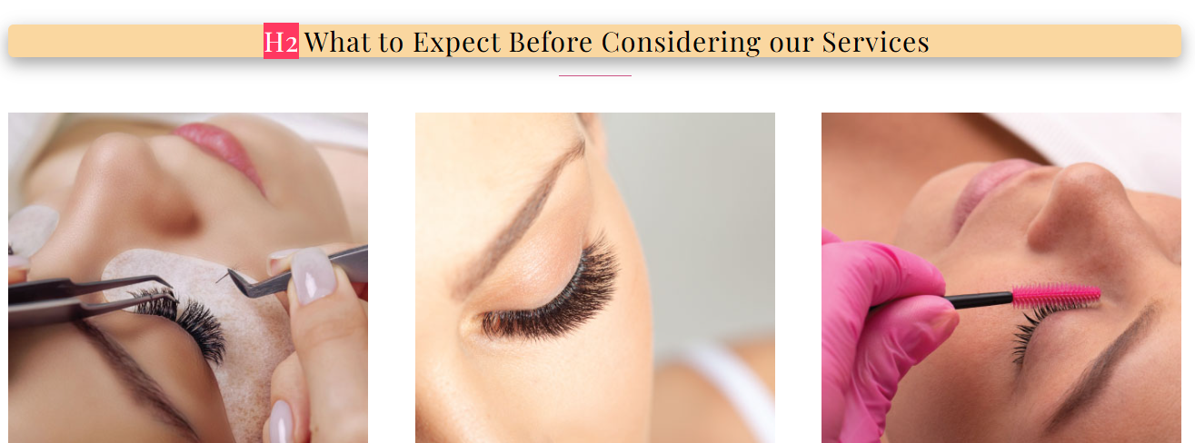
Plz rewrite this heading.
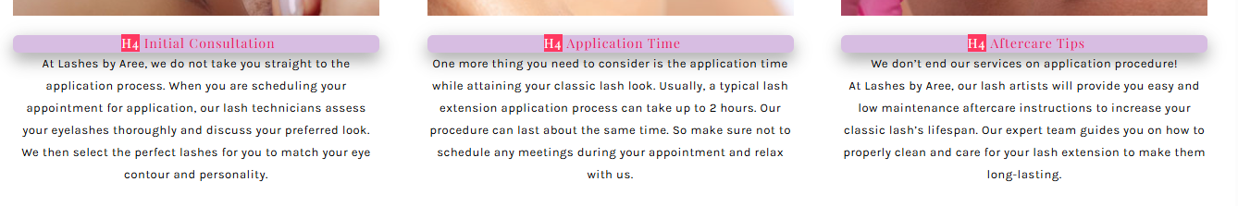

Give yourself a Classy Makeover with our Classic Lash Extensions (H2)

Get your natural classic lash extensions done by our expert technicians and enhance your look effortlessly. Here, at Lashes by Aree, our skilled artists will help you get your classic lash look, whether you want them for a special event or just a subtle lash lift for everyday wear. Our natural classic lashes will help you achieve the look of your dreams with affordability. Not only that, Lashes by Aree also provides hands-on assistance throughout the application of the natural eyelash extension procedure. You also get after-care instructions to make these natural eyelash extensions last longer. Transform your style with us and make a significant change in your entire appearance through our before and after classic lash extensions.

Adjust the focus and secondary keywords in this section. If need to write plz do.
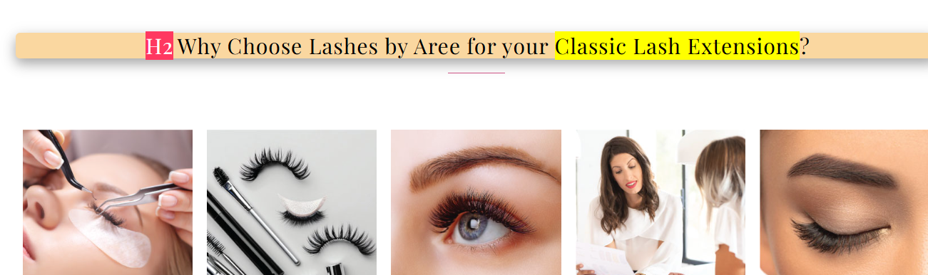

Experience the Best Classic Lash Extensions(H2)

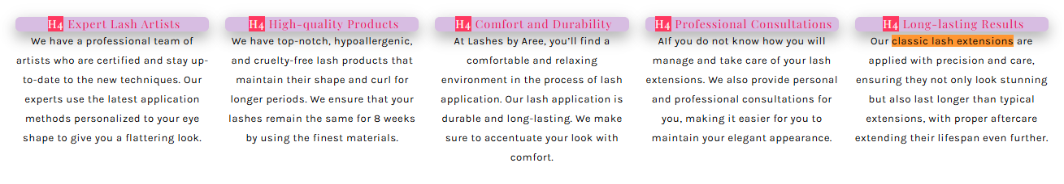

Expert Lash Artists (H3)
We have a professional team of artists who stay up-to-date with the latest classic lash fills and custom styles. Our experts use the latest application methods personalized to your eye shape to give a stunning look.

High-quality Products (H3)
We have top-notch, hypoallergenic, and cruelty-free lash products that maintain their shape and curl for longer periods. We ensure that your lashes remain the same for 8 weeks by using the finest materials.

Comfort and Durability (H3)
At Lashes by Aree, you’ll find a comfortable and relaxing environment in the process of lash application. Our natural classic lash extensions prioritize comfort and longevity by offering durable and stunning results.

Professional Consultations (H3)
If you do not know how you will manage and take care of your lash extensions. We also provide personal and professional consultations for you, making it easier for you to maintain your elegant appearance.

Long-lasting Results (H3)
Our classic lash extensions are applied with precision and care, ensuring they not only look stunning but also last longer than typical extensions, with proper aftercare extending their lifespan even further.

